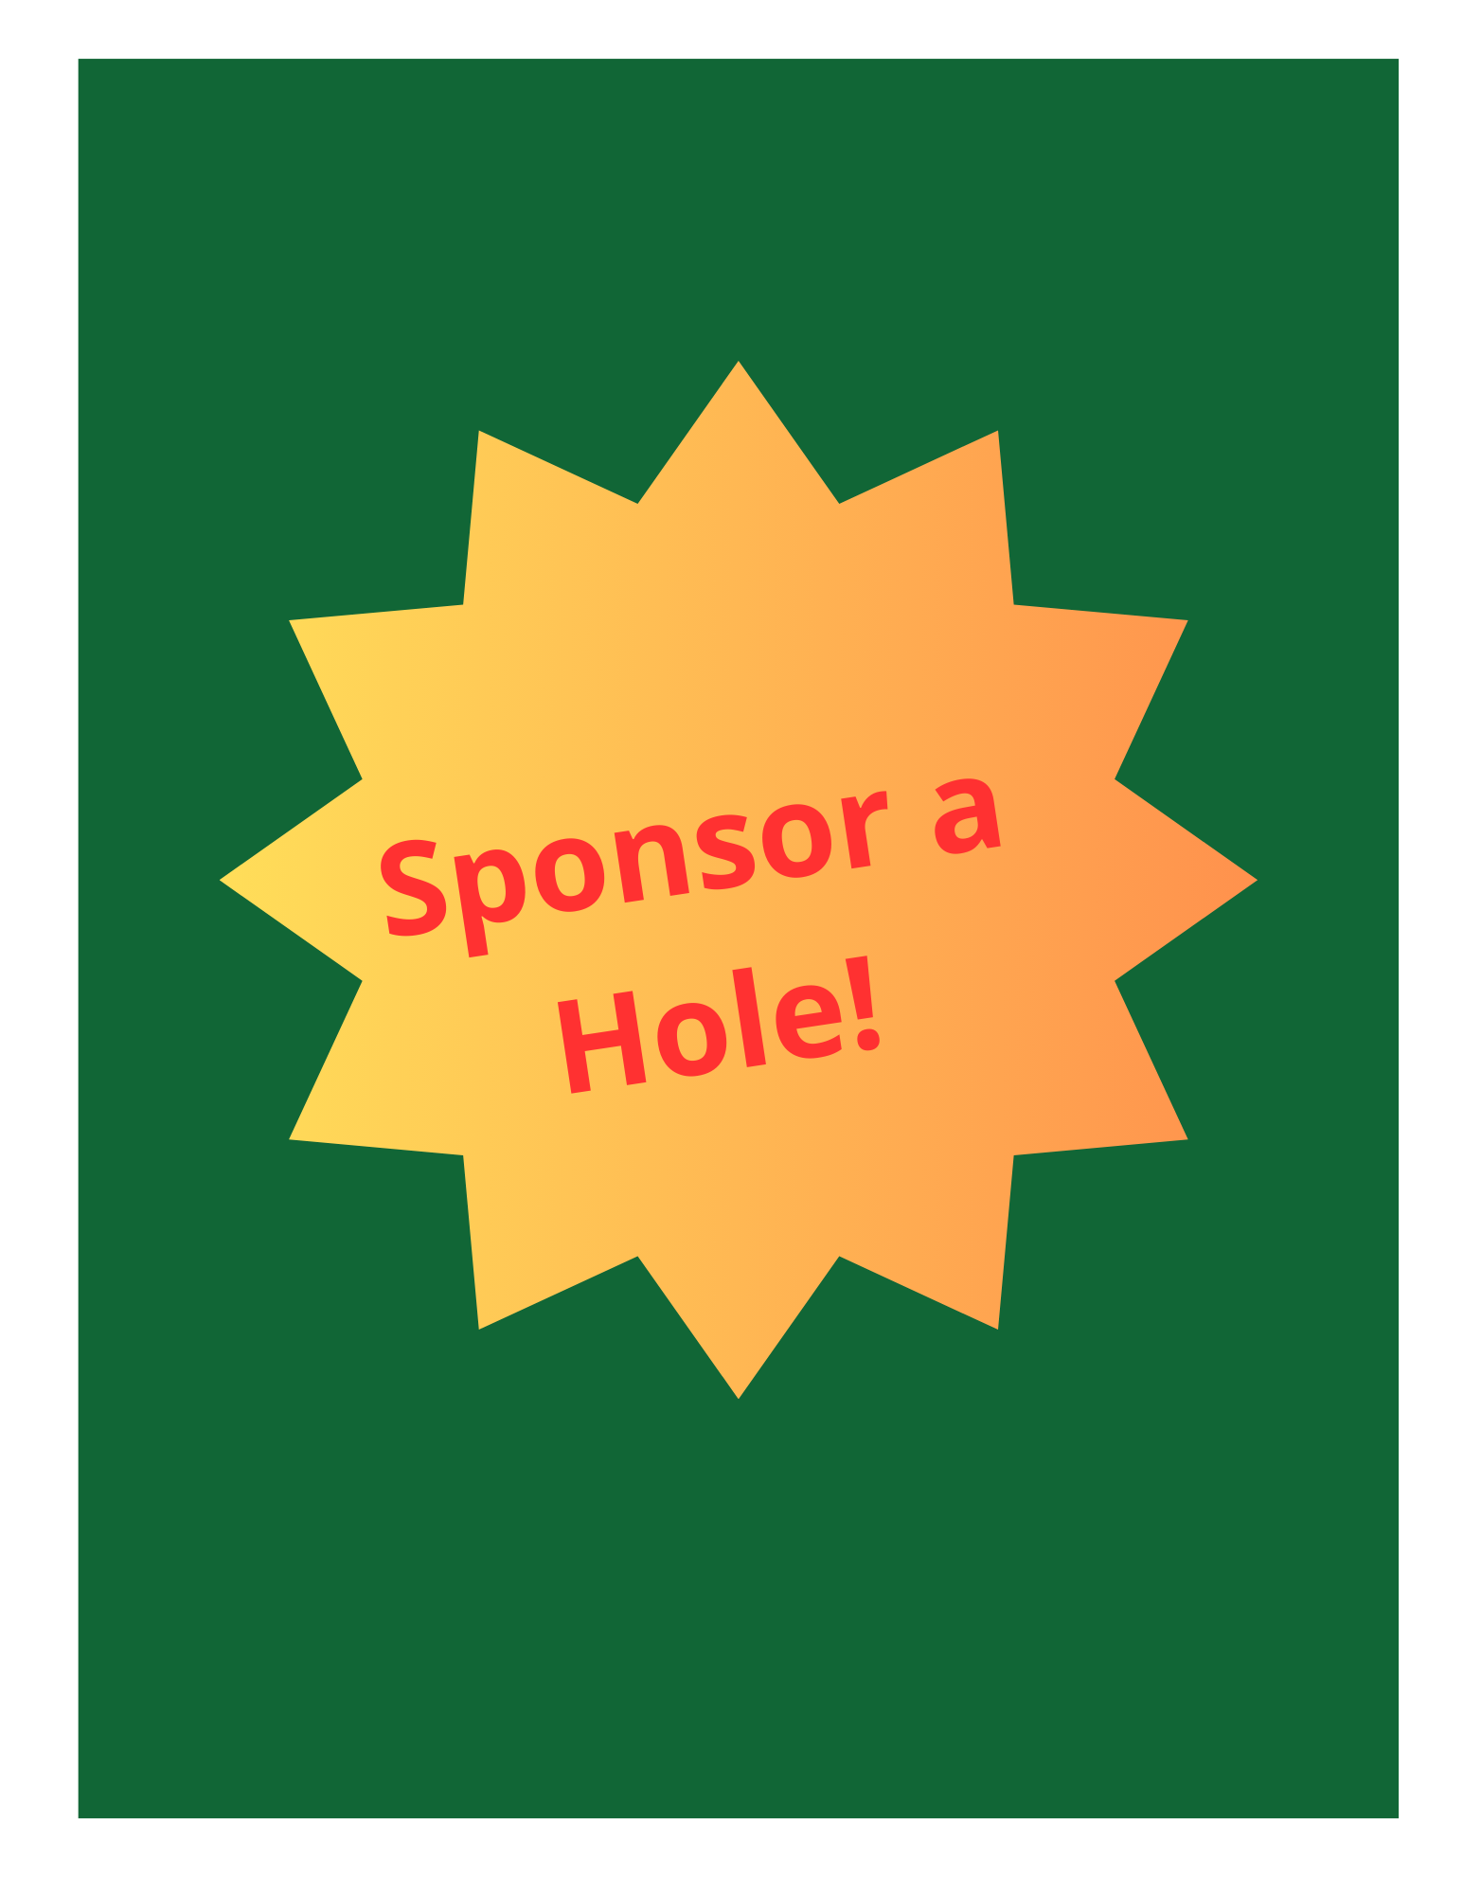


10 high school students and 2 adults from Iowa City are going to the Notre Dame Vision conference in Indianapolis this fall.

You can help lower the cost of our trip, while advertising your business!

Hole sponsorship options:
$100 Sign with your business’s name/logo displayed at one of the 18 holes
$200 Sign at a hole PLUS, after the event, acknowledgement in the parish bulletin and on a sign in the narthex so parishioners see it when they come for Mass
$300 All of the above PLUS giveaway pens to be handed out at your hole with your
business’ name/logo (must sign up for this level by May 8th )

Contact Sofia Livorsi, youth group coordinator at St. Patrick’s: sofia@stpatsic.com

